CSA 283: Exam Two

Name: ______________________________________ Section: _____ _____

Please write legibly. Ask questions if something is unclear. Write down any assumptions you make.

EXAM IS PRINTED ON BOTH SIDES OF THE PAGE.

- Give definitions for the following terms using one or two sentences. If the term is includes an acronym, also state what the letters in the acronym stand for. (15 points)

a. Congestion Window:

b. Dual Stack

c. Intra-AS Routing Protocol:

d. Sample RTT

e. Virtual Circuit Number (VC Number)

- Consider following segments:

Segment One Characteristics:
  - Source address: IP1
  - Destination address: IP3
  - Source port 100
  - Destination port 400.
- Segment Two Characteristics:
  - Source address: IP1
  - Destination address: IP3
  - Source port 100
  - Destination port 500.

    - Would it be possible for these two segments to have been transmitted using TCP? Why or why not? If it is possible, could the two segments be received by the same socket? (4 points)

    - Assuming that both packets reach their final destination and are transmitted using UDP, will the two UDP packets be received by the same socket? Why or why not? (4 points)

- Host A has calculated the congestion window to be 11,000 bytes. The receive window for Host B to which the host A is sending data is 12,000 bytes. Host A has transmitted 10,000 bytes of data. 9,000 of these bytes have been acknowledged. What is the maximum number of bytes Host A can transmit to Host B at this time? Explain/show your reasoning. (4 points)

- How is the receive window calculated? Why is it important? (4 points)

- A block of data for transmission using the TCP protocol has been broken up for transmission into four separate segments.
- The sequence number of the first segment is 1500.
- The first segment contains 400 bytes.
- The second segment contains 200 bytes.
- The third segment contains 300 bytes
- The fourth segment contains 400 bytes

- Complete the following table by writing the correct sequence number for each segment and the sequence number that would be used by the receiver to indicate in order receipt of each segment (Nothing is lost. All arrive in order.) (8 points)

 | Segment Sequence Number | Acknowledgement Number
First Segment
Second Segment
Third Segment
Fourth Segment

Recall that TCP uses cumulative acks. Suppose that segments actually arrive at the receiving end in the following order.

First segment, Third segment, Fourth Segment, Second Segment

- Give the TCP acknowledgement that will be sent for each segment if the receiver is using a Go-Back-N protocol. (4 points)

_______ First segment

_______ Third segment

_______ Fourth Segment

_______ Second Segment

- Give the TCP acknowledgement that will be sent for each segment if the receiver is using a Selective-Repeat protocol. (4 points)

_______ First segment

_______ Third segment

_______ Fourth Segment

_______ Second Segment
- Below is a simple network diagram. The network includes three hosts (A, B, and C) and one router that are part of a LAN and single host (Z) that is located in the Internet. The router is performing Network Address Translation (NAT) using the NAT table below the figure.

In response to a “Get” request from C, a web server application running on host Z using a socket tied to port 80 sends a segment back to an application on C that is using a socket on port 4600. After the segment is received by the application on C, C sends a segment back to the application running on Z.
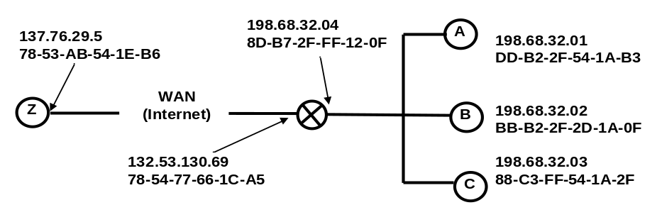
Figure 1: Simple Network with a Router Using the NAT Protocol

NAT Translation Table
WAN side address | LAN side address
132.53.130.69, 4500 | 198.68.32.01, 3340
132.53.130.69, 3250 | 198.68.32.03, 4600
132.53.130.69, 2200 | 198.68.32.02, 1500
… | …
Fill in the source and destination IP addresses and port numbers that will be carried in datagrams at the following four points in the network. (12 points)

 | Z to C |  |  | C to Z
 | From Z to router | From router to C | From C to router |  | From router to Z
Source IP
Source Port
Dest. IP
Dest. Port
- TCP congestion control uses the number of duplicate acks and timeouts to determine the transmission rate. Assume the following events:

- Transmission of data begins at time 0 (RTT 0) with a congestion window size equal to 1 MSS (Maximum Segment Size).
- A timeout event occurs between RTT 4 and RTT 5.
- Three duplicates acks are received between RTT 10 and RTT 11.
- Positive acks received during all other RTT intervals

Write the size of the congestion window and the threshold for each RTT period in terms of MSS. The CongWin should be adjusted at the end of each RTT interval based on what happens in the interval. (12 points)

Time | Size of congestion Window (CongWin) in Maximum Segment Sizes (MSS) | Threshold in MSS
0 RTT | 1 | ∞
1 RTT
2 RTT
3 RTT
4 RTT
5 RTT
6 RTT
7 RTT
8 RTT
9 RTT
10 RTT
11 RTT
12 RTT
- Below is a portion of a routing table.

Prefix | Link Interface
11001111 10010111 1001 | 0
11001111 10010011 10011101 | 1
11001111 10010011 10010 | 2
Otherwise | 3

- Give the Classless InterDomain Routing (CIDR) notation for the subnets identified by the first two rows of the table (for example 200.23.16.0/23). Indicate approximately how many hosts each sub-net could contain.
(8 points)

CIDR notation Approx. Number of Hosts

________________________ __________

________________________ __________

- Using the destination IP addresses, determine which link interface each of the following packets should be sent to. (6 points)

Destination IP Address | Link Interface
11001111 10010111 10011001 11011101
11001101 00010101 00011000 10101101
11001111 10010111 10010100 00011000

- Describe the service provided by a DHCP server using one or two sentences. (4 points)

- Describe how DHCP works by stating the sender and purpose of each message used in the typical DHCP sequence. (8 points)
- Use the distance vector algorithm to update A’s forwarding table.

- Routers are identified by upper case letters i.e. A, B, C, D, E, etc.

- Subnets (destinations) are identified by lower case letters i.e. s, t, u, v, w, y, z.

- The neighbors of a router are one hop (one subnet) away.

The following is the routing table at router A:

Destination Subnet | Next Router | Number of Hops to Dest.
s | B | 4
t | G | 3
u | - | 1
v | B | 4
w | D | 3
y | G | 5

Assume that router A receives the following advertisement from neighbor B:

Destination Subnet | Next Router | Number of Hops to Dest.
s | R | 2
t | - | 2
u | - | 1
y | Q | 7
z | F | 4

As a result of the above advertisement, A may (or may not) change its routing table. Show A’s updated routing table below: (14 points)

Please list the destinations in alphabetical order.

Destination Subnet | Next Router | Number of Hops to Dest.

- Place Xs in the following table to indicate what transport layer mechanism is used to deal with various types of transmission errors. If a mechanism is not applicable leave the cell blank. Assume numerous pipelined segments.
(16 points)
 | UDP |  |  | TCP
 | Checksums | Timers | Sequence Numbers | Checksums | Timers | Sequence Numbers
Lost Packets
Duplicate
Packets
Corrupt Packets
Out of Order Packets

- Assume the following group of IP fragments has been received. Each has a header with a length of 20 bytes.
 | Length | ID | Frag Flag | Offset
… | 740 | 20 | 1 | 0 | …
… | 740 | 22 | 1 | 90 | …
.. | 500 | 20 | 0 | 180 | …
 | 740 | 18 | 0 | 0
 | 560 | 22 | 0 | 180

- Are all the fragments from the same segment? If not, how many segments.(3 points)

- Has all the data been received? If not, give the missing ranges of bytes for each of the original segments involved? (9 points)

- If some fragments of a datagram are corrupted, what will the IP protocol do with uncorrupted fragments that are received? (3 points)

